T H E N E W I N N
L U N C H M E N U
Sandwiches
Bacon & egg £6.50
Tuna mayo £6.50
Sausage & Red onion chutney £6.50
Chedder Cheese & Tomato £7.00
(with a side of tomato cutney)
BLT £7.50
Ale battered cod fingers £8.50
- all sandwiches served with petite salad & house fries -
Jacket Potatoes
Cheese & baked beans £5.00
Tuna mayo £5.50
Cheese & coleslaw £5.50
Chilli £7.00
- all baked jacket potatoes served with salad garnish –
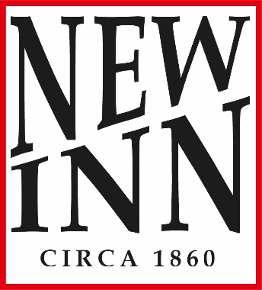
Others
Red onion & gruyere tartlet with salad £7.50
Chicken caesar salad (with or without anchovies) £9.95
Add Bacon £1.00
Prawn marie rose salad with a bread roll £9.95
Mushroom soup with bread £5.00
Beef burger, chips & purple coleslaw £10.50
BBQ chicken burger, chips & purple coleslaw £11.50

Before you order food or drinks, please let us know of any allergies or intolerances and we will be happy to tell you what ingredients are in each dish or drink.

